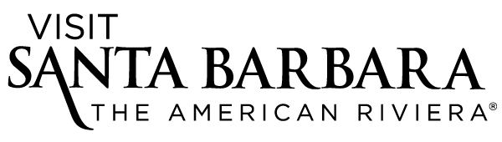

CONTACT: Karna Hughes, Director of Communications Jaime Shaw, Communications Manager
Visit Santa Barbara Visit Santa Barbara
(805) 966-9222, ext. 112 (805) 966-9222, ext. 107 karna@santabarbaraCA.com jaime@santabarbaraCA.com

VISIT SANTA BARBARA WINS TWO U.S. TRAVEL ASSOCIATION AWARDS
Brighten Your Day Campaign Recognized for Excellence and Innovation

Santa Barbara, Calif. (Sep. 2, 2015) — Visit Santa Barbara received two prestigious U.S. Travel Association awards for its innovative Brighten Your Day marketing campaign. The honors were presented Aug. 25 in Portland, Ore., during an awards dinner at ESTO (Educational Seminar for Tourism Organizations), an annual conference for travel professionals representing destinations throughout the U.S.

Visit Santa Barbara, the Destination Marketing Organization (DMO) for the Santa Barbara region, received Destinations Council Destiny Awards for best Branding & Integrated Marketing Campaign and best Social Media Campaign. The awards recognize local- and regional-level DMOs for excellence and creative accomplishment in marketing destinations to tourists.

“I’m thrilled that Visit Santa Barbara’s Brighten Your Day campaign was honored with two awards by the U.S. Travel Association – the premier industry organization of our DMO peers,” said Kathy Janega-Dykes, Visit Santa Barbara’s president/CEO. “In partnership with MMGY Global and Sparkloft Media, our marketing team created and executed a campaign that connected in a meaningful way with prospective visitors. Months of hard work paid off with great results from both the integrated paid-media and social media campaigns.”

The Brighten Your Day campaign was created to drive visitation to Santa Barbara during the off-season of November through March in the 2014-15 fiscal year and focused primarily on cold-weather markets. Designed to connect with consumers on an emotional level, the campaign promoted not only the ideal weather of Santa Barbara but the unique personality of the destination. In a Brighten Your Day experiential activation event in Seattle, Visit Santa Barbara staffers brought fun, sun and “surprise and delight” tactics to the typically rain-drenched city, such as treating unsuspecting passersby to free Santa Barbara coffee and sunflowers, along with other Santa Barbara-centric gifts.

MMGY Global, Visit Santa Barbara’s advertising agency of record, created the strategy behind the campaign, which generated digital banners, email and print advertising totaling 5.4 million online media impressions; a print circulation of 816,000; nearly 30,000 visits to the dedicated website BrightenYourDaySB.com and reached 561,811 consumers via dedicated, bimonthly emails.

Created in conjunction with VSB’s social media agency Sparkloft Media, the social media campaign surprised fans and followers in various markets online with “social sunshine” (Santa Barbara gifts and giveaways) for engaging with the #BrightenYourDay hashtag. It led to more than 7.1 million potential impressions, 1,200 competition entries and a total campaign engagement of 36,222 – the most engaged-with campaign VSB’s social channels have seen to date.

Visit Santa Barbara’s 2015-16 marketing plan builds on the success of Brighten Your Day with a new campaign, I Shine in Santa Barbara. Similar to the Seattle in-market activation, VSB will take I Shine in Santa Barbara on the road to three consumer events within Santa Barbara’s drive markets in order to reach affluent, engaged consumers who are interested in art, culture, food, wine and outdoor activities. It kicks off with the Sausalito Art Festival Sept. 5-7 in the San Francisco Bay Area and a new microsite, IShineSB.com.

ABOUT VISIT SANTA BARBARA
Visit Santa Barbara is a nonprofit 501(c)(6) organization jointly funded by the City of Santa Barbara, the County of Santa Barbara, the South Coast Tourism Business Improvement District (TBID) and a membership of hospitality-related businesses. The primary mission of Visit Santa Barbara is to enhance the economies of the City of Santa Barbara, South Coast communities and Santa Barbara County areas through tourism marketing that increases business revenue, tax revenue and creates jobs.

ABOUT SANTA BARBARA
Voted “Best Beach Town” by Sunset magazine in its inaugural travel awards in May 2015 and selected as one of Condé Nast Traveler’s “30 Best Small Cities in America” in its recent Readers’ Choice Awards, Santa Barbara is located just 92 miles north of Los Angeles and 332 miles south of San Francisco, on the Pacific coastline. Visitors can arrive via scenic Highway 101, train, bus or by flying into Santa Barbara Municipal Airport (SBA) or Los Angeles International Airport (LAX). For travel and accommodation information and to request a free copy of the official Santa Barbara Visitors Magazine, contact Visit Santa Barbara at (800) 676-1266 or (805) 966-9222, email tourism@santabarbaraca.com or visit SantaBarbaraCA.com. Visitor information is also available at the Visitor Center, 1 Garden St. (at Cabrillo Boulevard).
####

Photos from ESTO awards dinner available:

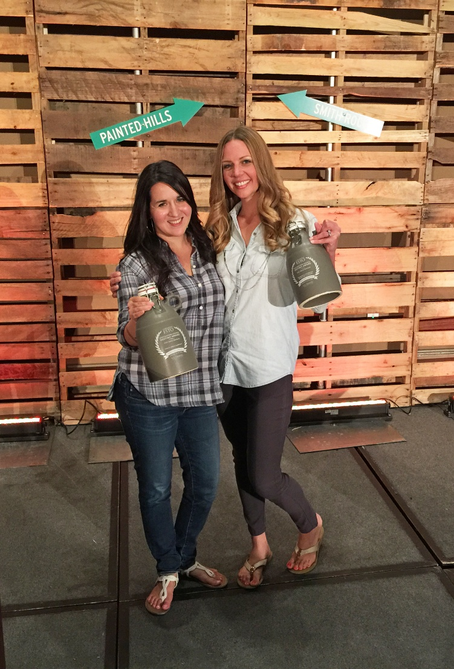

1) Photo file name: VisitSantaBarbara_ESTOawards2015
Photo credit: Visit Santa Barbara / Jen Trupiano

Caption: Visit Santa Barbara’s Digital Marketing Manager JessyLynn Perkins, left, and Marketing Manager Noelle Buben celebrate two U.S. Travel Association awards during the ESTO conference awards dinner. Held in Portland, Ore., the Aug. 25 event had a Portland hipster theme, with a flannel dress code and growlers bestowed in place of award trophies.

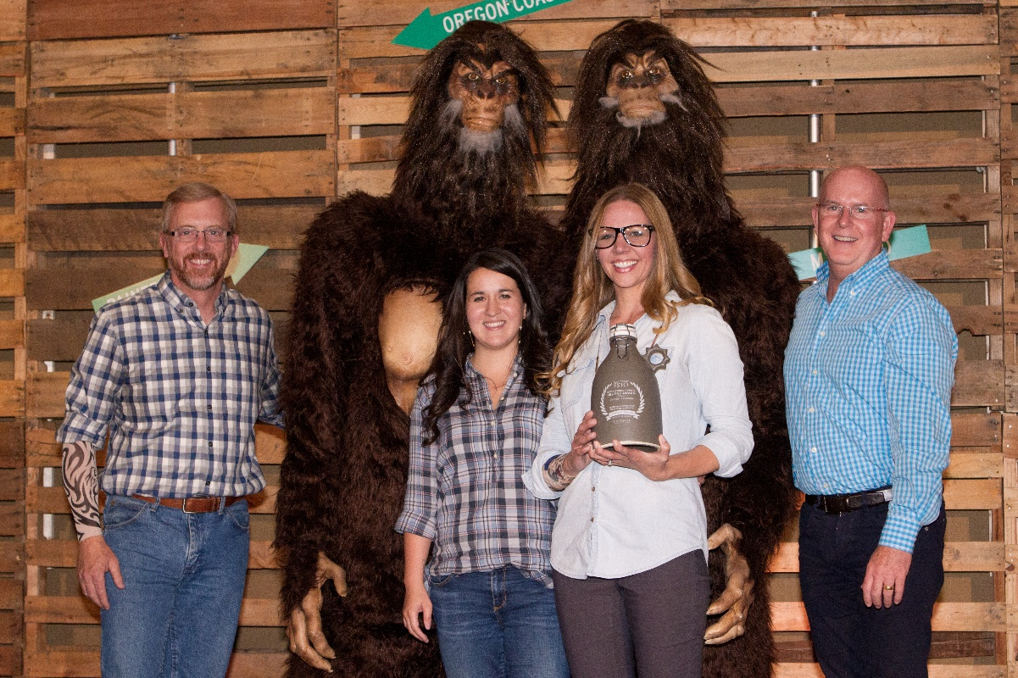

2) Photo file name: VisitSantaBarbara_ESTOawards2015_2
Photo credit: U.S. Travel Association

Caption: From left, Travel Oregon CEO Todd Davidson, Visit Santa Barbara Digital Marketing Manager JessyLynn Perkins, VSB Marketing Manager Noelle Buben and Travel Portland President Jeff Miller celebrate Visit Santa Barbara’s U.S. Travel Association Awards with their Bigfoot friends during the ESTO conference awards dinner in Portland, Ore. The Aug. 25 event had a Portland hipster theme.

