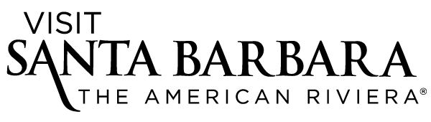

**MEDIA CONTACT:**

Karna Hughes, Director of Communications

Visit Santa Barbara

(805) 966-9222 ext. 112, [karna@santabarbaraCA.com](mailto:karna@santabarbaraCA.com)

Jaime Shaw, Communications Manager

Visit Santa Barbara

(805) 966-9222 ext. 107, [jaime@santabarbaraCA.com](mailto:jaime@santabarbaraCA.com)

**PUBLIC CONTACT:**

Visit Santa Barbara

(805) 966-9222

[www.epicuresb.com](http://www.epicuresb.com)

**Three Weeks Left to Experience epicure.sb,**

**Santa Barbara South Coast’sMonth-long Culinary Celebration**

*Restaurants, tour operators, hotels and more create special offers around “A Perfect Pairing” theme*

**Santa Barbara, CA (Oct. 12, 2015)** **—** What makes for a perfect pairing? Whether it’s chocolate and wine, tamales and tequila, or surf and sand, Santa Barbara has all these and more in store for culinary explorers during **epicure.sb**, a month-long celebration of the South Coast’s culture, cuisine and libations taking place now through Oct. 31.

Last week, in the “Quickfire Cooking Challenge with Cat Cora” — a signature epicure.sb event — three contestants waged culinary battle at Santa Barbara Public Market. Blogger Marla Meridith won the competition, judged by celebrity chef Cat Cora and *TravelZoo* senior editor Gabe Saglie, with her tasty red curry.

The foodie festivities continue with exclusive taste experiences, events and promotions at Santa Barbara-area restaurants, tasting rooms, attractions and hotels inspired by the seventh annual epicure.sb theme, “the perfect pairing.” With close to 60 businesses participating this year, visitors can enjoy a different epicure.sb experience every day through the end of October.

Still to come are some of the region’s most popular epicurean festivals, including the [**Santa Barbara Harbor & Seafood Festival**](http://www.harborfestival.org/) (Oct. 17) and the [**Santa Barbara Beer Festival**](http://www.sbbeerfestival.com/) (Oct. 17). Others not to be missed include:

**Culinary Adventures:**

* **Bike and Beer Tour** (daily in October, $159): Santa Barbara Adventure Co. offers up the perfect pairing for beer lovers who like to stay active – a bike and beer tour. Enjoy Santa Barbara’s emerging craft beer scene with a tour of several Funk Zone breweries and a picnic lunch.
* **“Everything Blueberry” Tasting** (daily in October, $10 to $20): Enjoy fresh farm-picked blueberries, blueberry jam and syrup, blueberry port wine and blueberry sorbet at Cebada Wines. For the perfect pairing, add on a vertical wine flight.
* **Tamales and Tequila Tasting: "Secrets of a Tamale Chef"** (Oct. 25, $30): In this special class held downtown, Chef-Owner Richard Lambert of Santa Barbara Tamales To-Go teaches the techniques he uses to make his award-winning tamales and salsas. Attendees will be served three samples, each paired with a variety of Tequila Alquimia, a cognac-like sipping tequila.

**Delectable Dinners:**

* **“Food Anthropology: The History of Santa Barbara as Told Through Food & Art”** (Oct. 23, $185): Enjoy a four-course candle-lit meal in historic Santa Barbara County Courthouse’s newly restored Mural Room while learning about four pivotal moments in Santa Barbara history depicted on its walls. Art and ingredients meld deliciously into one, as the menu, prepared by Montecito Country Club’s Michael Blackwell, draws inspiration from the mural. The event benefits Casa del Herrero, a National Historic Landmark.
* **“Tahitian Nights” at Salt Cave Santa Barbara** (Oct. 23, $25): Spend an intimate evening in the rosy glow of Santa Barbara’s own Himalayan salt cave, while enjoying Tahitian-inspired cuisine prepared by Santa Barbara chef Alvaro Rojas (Milk and Honey, Alcazar), accompanied by live music.
* **“Mastering the Art of Modern French Cuisine”** (Oct. 24, $95): Enjoy a delicious four-course meal by Bacara Resort & Spa’s new executive chef, Vincent Lesage, paired with wine. Guests will be treated to a modern take on classic French recipes by legendary cookbook author and late Santa Barbara resident Julia Child.
* **“Santa Barbara Surf & Turf”** (daily in October, $45): Can’t decide between steak or seafood? You don’t have to with this perfect pairing. Rodney’s Grill at The Fess Parker: A Doubletree by Hilton Resort offers a three-course surf and turf dinner.
* **“Jaffurs Big 3 and Small Plates”** (daily in October, $49): Enjoy three exceptional wines from Jaffurs Wine Cellars paired with small plates of surf, turf and vegetables at The Black Sheep restaurant in downtown Santa Barbara.

**Sumptuous Sips:**

* **Rooftop Wine Series Finale** (Oct. 12, $35): Just about anything is the perfect complement to the spectacular views enjoyed on the Canary Hotel’s rooftop. As the summer rooftop wine series winds down, take in ocean to mountain views with local wine, food by Canary Chef James Siao and/or a specialty cocktail.
* **“Earth Meets Fire”** (daily in October):S.Y. Kitchen’smixologist Alberto Battaglini has created a dazzling new cocktail pairing elements of earth and fire.
* **American Riviera Wine & Chocolate Flight** (daily in October, $20): Chocolate lovers rejoice. Jamie Sloane Wines offers premium red wines served with chocolate from local French chocolatier Jean-Michael Carré’s Chocolats du Calibressan.

**Twice as Nice:**

* **“When You Just Need to Float…The Perfect Pairing”** (daily in October, $210): Treat yourself to the perfect pairing of a massage and a facial at Float Luxury Spa in downtown Santa Barbara.
* **ATV Adventure for Two** (daily in October): Join Enjoy the Mountain for an unforgettable ATV ride in the Los Padres National Forest. Make it the perfect pairing by bringing a friend and getting half off his/her ride.
* **Eye See Santa Barbara Two-for-One Special Photo Tours at the SB Courthouse** (Thursdays through Sundays in October, $55): The Santa Barbara Courthouse is one of the most photographed places in the city. Join Eye See Santa Barbara Photography Tours for a tour that teaches you how to capture breathtaking photographs. Bring a friend for a special two-for-one deal.

**Epic Stays:**

* **“Discover Downtown SB” Package** (midweek in October, $449): Stay at Hotel Santa Barbara, a historic boutique hotel in the heart of downtown. Pair your two-night midweek stay with dinner at Cadiz Restaurant & Lounge.
* **“Perfect Epic Pairing for $99”** (Sundays through Thursdays in October, $99): Ramada Santa Barbara pairs a midweek stay with its Value Pass. Save hundreds of dollars at local restaurants, wine tasting rooms, cultural attractions and more.
* **“Enchanted Getaway”** (daily in October, fee varies)combines Santa Barbara’s great food and wine with the romance and seclusion of Belmond El Encanto. Enjoy complete privacy in luxury accommodations while savoring a limited-edition, epicure.sb, prix-fixe menu with perfect wine pairings.
* **“Day to Night”** at Hotel Indigo offers guests a special care package (Sundays through Thursdays, $299) to explore Santa Barbara’s daytime delights, from the beach to the Museum of Contemporary Art, and end their perfect day with wine tasting and a relaxing night in a King guest room.

For a complete listing of offerings, visit www.epicuresb.com.

**ABOUT EPICURE.SB**Presented by Visit Santa Barbara, epicure.sb is designed to celebrate Santa Barbara’s abundant and diverse epicurean offerings. The annual promotion ties together the region’s signature culinary events taking place each October, while offering original programming that showcases regional cuisine, libations and culture. Visit www.epicuresb.com for a complete list of participating businesses and additional information.

**ABOUT SANTA BARBARA**

Voted [“Best Beach Town”](http://www.sunset.com/travel/sunset-travel-awards-beach-town) by *Sunset* magazine in its inaugural travel awards in May 2015 and selected as one of *Condé Nast Traveler*’s “[30 Best Small Cities in America](http://www.cntraveler.com/galleries/2015-07-29/the-30-best-small-cities-in-america-readers-choice-awards-2014)” in its Readers’ Choice Awards, Santa Barbara is located just 92 miles north of Los Angeles and 332 miles south of San Francisco, on the Pacific coastline. Visitors can arrive via scenic Highway 101, train, bus or by flying into Santa Barbara Municipal Airport (SBA) or Los Angeles International Airport (LAX). For travel and accommodation information and to request a free copy of the official *Santa Barbara Visitors Magazine*, contact Visit Santa Barbara at (800) 676-1266 or (805) 966-9222, email [tourism@santabarbaraca.com](mailto:tourism@santabarbaraca.com) or visit [SantaBarbaraCA.com](http://www.santabarbaraca.com). Visitor information is also available at the Visitor Center, 1 Garden St. (at Cabrillo Boulevard).

# # #

**PHOTOS**

**High-res photos available at** <https://www.dropbox.com/sh/rlxwtqxklvthnij/AADo07L1-BVegIYTb9C0u3Y1a?dl=0>. Contact [PR@santabarbaraca.com](mailto:PR@santabarbaraca.com) for additional images.

**Thumbnails:**

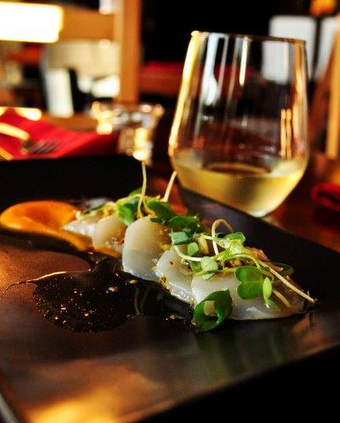 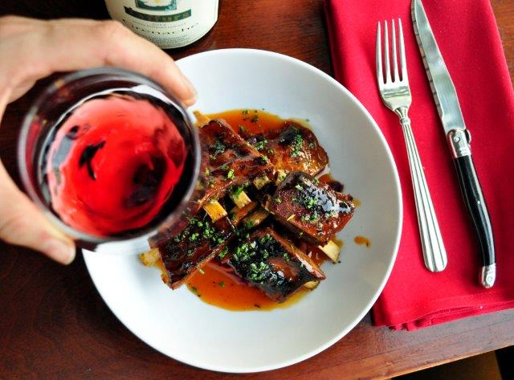 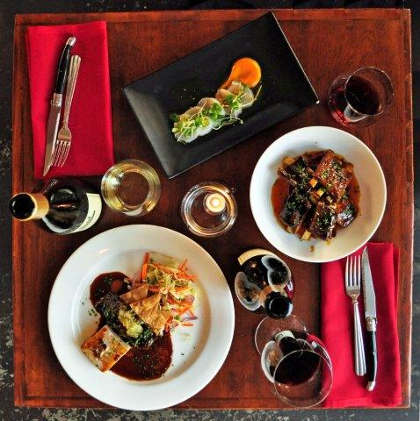

**File names:** From left, epicure.sb_Jaffurs_1st_course, epicure.sb_Jaffurs_2nd_course, epicure.sb_Jaffurs_all3_courses

**Caption:**

As part of Santa Barbara’s epicure.sb culinary celebration, Jaffurs Wine Cellars pairs three exceptional wines with small plates from The Black Sheep restaurant throughout October.

**Credit:**

Courtesy of Visit Santa Barbara

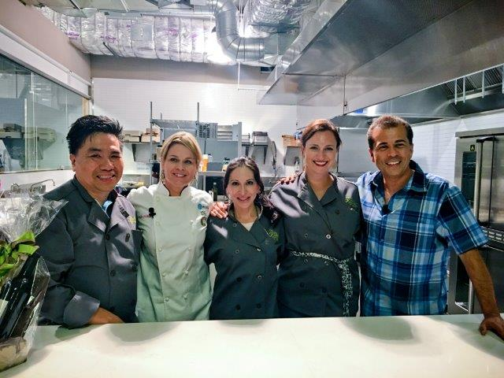

**File name:** 1510_CatCoraQuickfire_photoEyeSeeSB_AndreinaDiaz

**Caption:**

The “Quickfire Cooking Challenge with Cat Cora,” one of epicure.sb’s signature events, took place Oct. 8 at the Santa Barbara Public Market. The epicure.sb culinary celebration continues throughout the month of October.

**Credit:** ©Andreina Diaz / Eye See Santa Barbara

**MEDIA INFORMATION**Stay informed about Santa Barbara news with our [Media Center](http://www.santabarbaraca.com/media/), [press releases](http://www.santabarbaraca.com/media/press-releases/) and blog, [TheSBPost.com](http://www.thesbpost.com/). Just getting to know Santa Barbara? The [Media Field Guide](http://www.nxtbook.com/nxtbooks/cmg/santabarbara_mediafieldguide/) is a great place to start. Planning a research visit? Use the [Press Trip Request](http://www.santabarbaraca.com/media/press-trip-request/) form to get the process started. Follow us on [Facebook](http://www.facebook.com/visitsantabarbara) and [Twitter](http://www.twitter.com/SantaBarbara) for daily updates, and visit our [Mobile Site](http://www.santabarbaraca.com) for on-the-go information about dining, wine, accommodations, events, attractions and more.